LAB EXPERIMENTS

NAME :Bemanaveni Manish
REG NO :192411149
COURSE NAME : INTERNET PROGRAMMING
COURSE CODE :CSA4308

1 . LIBRARY MANAGEMENT SYSTEM

<!DOCTYPE html>
<html>
<head>
<title>Library Management System</title>
<style>
body{font-family:Arial;background:#f2f2f2;margin:0}
header{background:#2c3e50;color:white;padding:20px;text-align:center}
nav button{padding:10px;margin:5px;background:#3498db;color:white;border:0}
.container{background:white;margin:30px auto;padding:20px;max-width:800px}
input,select{padding:10px;margin:8px;width:90%}
button{padding:10px;background:#3498db;color:white;border:0}
.book{background:#eee;padding:15px;margin:10px}
</style>
</head>

<body>

<header>
<h1>📚 Library Management System</h1>
<button onclick="home()">Home</button>
<button onclick="books()">Books</button>
<button onclick="login()">Login</button>
<button onclick="admin()">Admin</button>
</header>

<div class="container" id="content">
<h2>Welcome to College Library</h2>
<p>Search, borrow and manage library books easily.</p>
</div>

<script>

function home(){
document.getElementById("content").innerHTML=
"<h2>Library Home</h2><p>Welcome Students and Librarians!</p>";
}

function books(){
document.getElementById("content").innerHTML=`
<h2>Search Books</h2>
<input id="search" placeholder="Search Book">
<div class="book"><h3>Java Programming</h3>
<p>Author: Herbert Schildt</p>
<p>Status: Available</p>
<button onclick="borrow()">Borrow</button></div>
<div class="book"><h3>Database Management</h3>
<p>Author: Silberschatz</p>
<p>Status: Available</p>
<button onclick="borrow()">Borrow</button></div>`;
}

function borrow(){
alert("Book Issued Successfully!");
}

function login(){
document.getElementById("content").innerHTML=`
<h2>User Login</h2>
<input placeholder="Email">
<input type="password" placeholder="Password">
<button onclick="alert('Login Successful')">Login</button>`;
}

function admin(){
document.getElementById("content").innerHTML=`
<h2>Librarian Admin</h2>
<input placeholder="Book Name">
<input placeholder="Author">
<input placeholder="Year">
<button onclick="alert('Book Added')">Add Book</button>
<h3>Manage Books</h3>
<button onclick="alert('Book Updated')">Update Book</button>
<button onclick="alert('Book Deleted')">Delete Book</button>
<h3>Issue / Return</h3>
<button onclick="alert('Book Issued')">Issue Book</button>
<button onclick="alert('Book Returned')">Return Book</button>
<h3>Fine</h3>
<input placeholder="Fine Amount">
<button onclick="alert('Fine Added')">Make Fine</button>`;
}

</script>

</body>
</html><!DOCTYPE html>
<html>
<head>
<title>Library Management System</title>
<style>
body{font-family:Arial;background:#f2f2f2;margin:0}
header{background:#2c3e50;color:white;padding:20px;text-align:center}
nav button{padding:10px;margin:5px;background:#3498db;color:white;border:0}
.container{background:white;margin:30px auto;padding:20px;max-width:800px}
input,select{padding:10px;margin:8px;width:90%}
button{padding:10px;background:#3498db;color:white;border:0}
.book{background:#eee;padding:15px;margin:10px}
</style>
</head>

<body>

<header>
<h1>📚 Library Management System</h1>
<button onclick="home()">Home</button>
<button onclick="books()">Books</button>
<button onclick="login()">Login</button>
<button onclick="admin()">Admin</button>
</header>

<div class="container" id="content">
<h2>Welcome to College Library</h2>
<p>Search, borrow and manage library books easily.</p>
</div>

<script>

function home(){
document.getElementById("content").innerHTML=
"<h2>Library Home</h2><p>Welcome Students and Librarians!</p>";
}

function books(){
document.getElementById("content").innerHTML=`
<h2>Search Books</h2>
<input id="search" placeholder="Search Book">
<div class="book"><h3>Java Programming</h3>
<p>Author: Herbert Schildt</p>
<p>Status: Available</p>
<button onclick="borrow()">Borrow</button></div>
<div class="book"><h3>Database Management</h3>
<p>Author: Silberschatz</p>
<p>Status: Available</p>
<button onclick="borrow()">Borrow</button></div>`;
}

function borrow(){
alert("Book Issued Successfully!");
}

function login(){
document.getElementById("content").innerHTML=`
<h2>User Login</h2>
<input placeholder="Email">
<input type="password" placeholder="Password">
<button onclick="alert('Login Successful')">Login</button>`;
}

function admin(){
document.getElementById("content").innerHTML=`
<h2>Librarian Admin</h2>
<input placeholder="Book Name">
<input placeholder="Author">
<input placeholder="Year">
<button onclick="alert('Book Added')">Add Book</button>
<h3>Manage Books</h3>
<button onclick="alert('Book Updated')">Update Book</button>
<button onclick="alert('Book Deleted')">Delete Book</button>
<h3>Issue / Return</h3>
<button onclick="alert('Book Issued')">Issue Book</button>
<button onclick="alert('Book Returned')">Return Book</button>
<h3>Fine</h3>
<input placeholder="Fine Amount">
<button onclick="alert('Fine Added')">Make Fine</button>`;
}
</script>
</body>
</html>

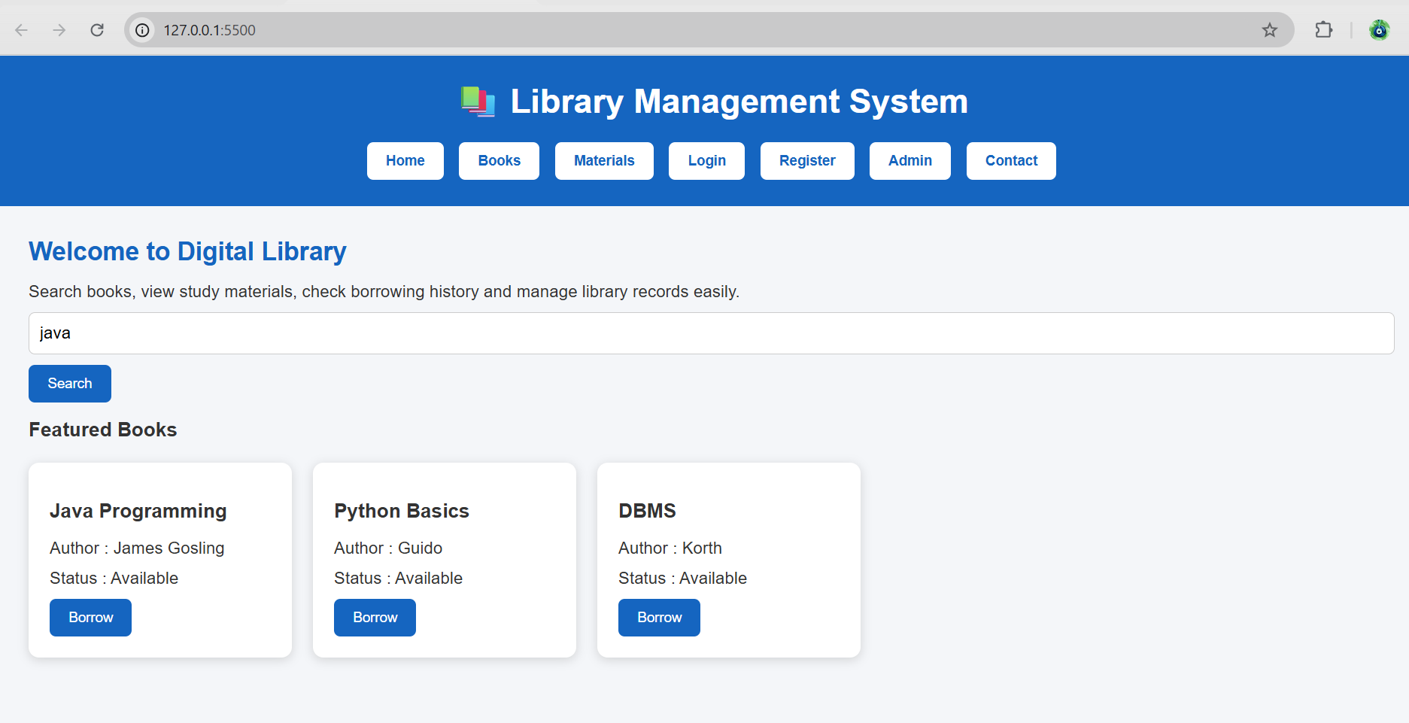
2. Hotel Room Booking

<!DOCTYPE html>
<html>
<head>
<title>Hotel Booking</title>
<style>
body{font-family:Arial;background:#eee;text-align:center}
header{background:#234;color:white;padding:20px}
button,input{padding:10px;margin:5px}
.room{background:white;margin:15px;padding:15px}
</style>
</head>
<body>

<header>
<h1>🏨 Hotel Room Booking</h1>
<button onclick="home()">Home</button>
<button onclick="rooms()">Rooms</button>
<button onclick="login()">Login</button>
<button onclick="booking()">My Bookings</button>
<button onclick="admin()">Admin</button>
</header>

<div id="app">
<h2>Welcome to Our Hotel</h2>
<p>Search and book your room easily.</p>
</div>

<script>
function home(){
app.innerHTML="<h2>Welcome to Our Hotel</h2><p>Comfortable rooms at best prices.</p>";
}

function rooms(){
app.innerHTML=`
<h2>Search Rooms</h2>
<input placeholder="Destination">
<input type="date"><input type="date">
<input placeholder="Guests">
<button onclick="alert('Room Available')">Check Availability</button>
<div class="room"><h3>Single Room</h3><p>$50 | WiFi | AC</p>
<button onclick="book()">Book Now</button></div>
<div class="room"><h3>Double Room</h3><p>$80 | WiFi | AC</p>
<button onclick="book()">Book Now</button></div>`;
}

function book(){
alert("Room booked successfully!");
}

function login(){
app.innerHTML=`
<h2>User Login</h2>
<input placeholder="Email">
<input type="password" placeholder="Password">
<button onclick="alert('Login Successful')">Login</button>
`;
}

function booking(){
app.innerHTML=`
<h2>My Booking</h2>
<p>Room: Double Room</p>
<p>Date: 10-08-2026</p>
<p>Status: Confirmed</p>
<button onclick="alert('Booking Modified')">Modify</button>
<button onclick="alert('Booking Cancelled')">Cancel</button>`;
}

function admin(){
app.innerHTML=`
<h2>Admin Panel</h2>
<input placeholder="Room Type">
<input placeholder="Quantity">
<input placeholder="Price">
<button onclick="alert('Room Updated')">Update Room</button>
<button onclick="alert('Booking Cancelled')">Cancel Booking</button>
<p>Admin can manage rooms, bookings and website pages.</p>`;
}
</script>
</body>
</html>
OUTPUT:
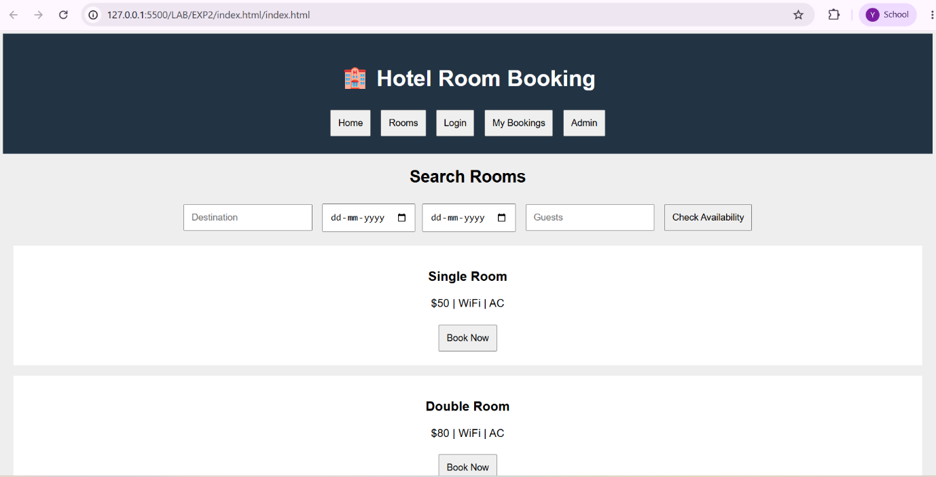

3.ONLINE BUS TICKET BOOKING
<!DOCTYPE html>
<html>
<head>
<title>Bus Ticket Booking</title>
<style>
body{font-family:Arial;background:#eee;text-align:center}
header{background:#234;color:white;padding:20px}
button,input,select{padding:10px;margin:5px}
.bus{background:white;margin:15px;padding:15px}
</style>
</head>
<body>

<header>
<h1>🚌 Bus Ticket Booking System</h1>
<button onclick="home()">Home</button>
<button onclick="search()">Search Bus</button>
<button onclick="login()">Login</button>
<button onclick="register()">Register</button>
<button onclick="booking()">My Booking</button>
<button onclick="admin()">Admin</button>
</header>

<div id="app">
<h2>Welcome to Bus Booking</h2>
<p>Search and book your bus ticket easily.</p>
</div>

<script>
function home(){
app.innerHTML="<h2>Welcome</h2><p>Book your bus tickets online.</p>";
}

function search(){
app.innerHTML=`
<h2>Search Bus</h2>
<input placeholder="From">
<input placeholder="To">
<input type="date">
<input type="time">
<button onclick="alert('Bus Found')">Search</button>
<div class="bus"><h3>Volvo Bus</h3>
<p>Chennai to Bangalore</p><p>Seats Available: 20</p>
<button onclick="book()">Book Ticket</button></div>`;
}

function book(){
alert("Ticket booked successfully!");
}

function login(){
app.innerHTML=`
<h2>Login</h2>
<input placeholder="Username">
<input type="password" placeholder="Password">
<button onclick="alert('Login Successful')">Login</button>
<p>Forgot Password? | Change Password</p>`;
}

function register(){
app.innerHTML=`
<h2>Registration</h2>
<input placeholder="Name"><input placeholder="Email">
<input placeholder="Password">
<button onclick="alert('Registered Successfully')">Register</button>`;
}

function booking(){
app.innerHTML=`
<h2>My Booking</h2><p>Bus: Volvo</p>
<p>Route: Chennai to Bangalore</p>
<button onclick="alert('Booking Cancelled')">Cancel Ticket</button>`;
}

function admin(){
app.innerHTML=`
<h2>Admin Panel</h2>
<input placeholder="Bus Type">
<input placeholder="Route">
<input placeholder="Available Seats">
<button onclick="alert('Bus Updated')">Update Bus</button>
<button onclick="alert('Report Generated')">Generate Report</button>
<p>Admin manages buses, users, comments and reports.</p>`;
}
</script>
</body>
</html>
OUTPUT:
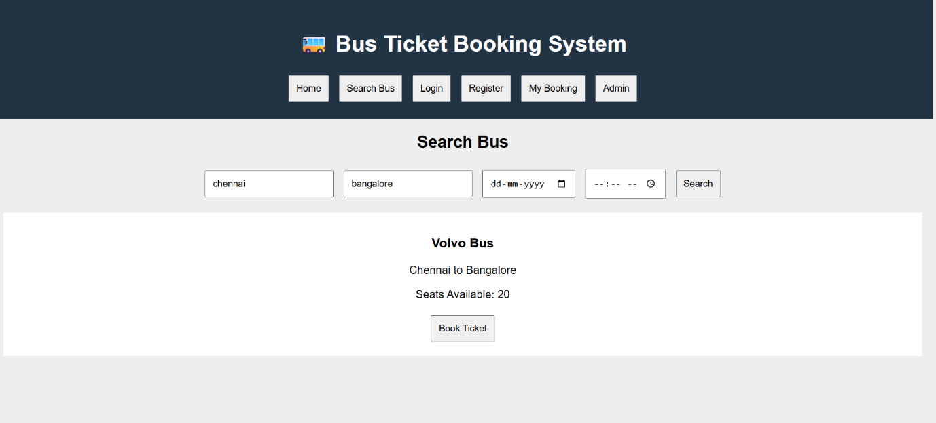

4. TRAIN RESERVATION SYSTEM:
<!DOCTYPE html>
<html>
<head>
<title>Train Reservation System</title>
<style>
body{font-family:Arial;background:#eee;text-align:center}
header{background:#234;color:white;padding:20px}
button,input,select{padding:10px;margin:5px}
.train{background:white;margin:15px;padding:15px}
</style>
</head>
<body>

<header>
<h1>🚆 Train Reservation System</h1>
<button onclick="home()">Home</button>
<button onclick="search()">Search Train</button>
<button onclick="login()">Login</button>
<button onclick="register()">Register</button>
<button onclick="pnr()">Check PNR</button>
<button onclick="admin()">Admin</button>
</header>

<div id="app">
<h2>Welcome to Railway Reservation</h2>
<p>Search trains and reserve your tickets online.</p>
</div>

<script>
function home(){
app.innerHTML="<h2>Welcome</h2><p>Book your train tickets easily.</p>";
}

function search(){
app.innerHTML=`
<h2>Search Train</h2>
<input placeholder="Origin Station">
<input placeholder="Destination Station">
<input type="date">
<select><option>AC</option><option>Sleeper</option><option>General</option></select>
<button onclick="alert('Train Found')">Search</button>
<div class="train"><h3>Express Train</h3>
<p>Available Seats: 25</p><p>Fare: $50</p>
<button onclick="book()">Book Ticket</button></div>`;
}

function book(){
alert("Ticket Booked! PNR: TR123456");
}

function login(){
app.innerHTML=`
<h2>Passenger Login</h2>
<input placeholder="Username">
<input type="password" placeholder="Password">
<button onclick="alert('Login Successful')">Login</button>`;
}

function register(){
app.innerHTML=`
<h2>Passenger Registration</h2>
<input placeholder="Name"><input placeholder="Email">
<input placeholder="Password">
<button onclick="alert('Registration Successful')">Register</button>`;
}

function pnr(){
app.innerHTML=`
<h2>Check PNR Status</h2>
<input placeholder="Enter PNR Number">
<button onclick="alert('Status: Confirmed')">Check Status</button>
<p>PNR Status: Confirmed / RAC / Waiting List</p>`;
}

function admin(){
app.innerHTML=`
<h2>Admin Panel</h2>
<input placeholder="Train Name">
<input placeholder="Train Number">
<input placeholder="Available Seats">
<button onclick="alert('Train Details Updated')">Update Train</button>
<button onclick="alert('Refund Processed')">Process Refund</button>
<p>Admin manages trains, fares, users, PNR and payments.</p>`;
}
</script>
</body>
</html>
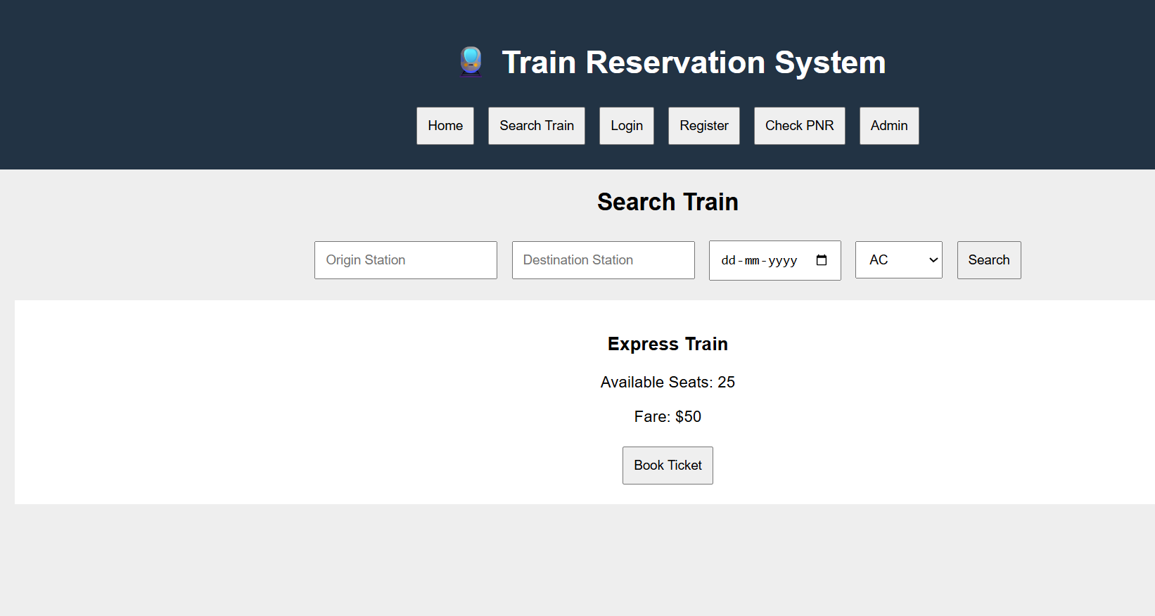

5. FLIGHT RESERVATION SYSTEM
<!DOCTYPE html>
<html>
<head>
<title>Flight Reservation System</title>
<style>
body{font-family:Arial;background:#eee;text-align:center}
header{background:#234;color:white;padding:20px}
button,input,select{padding:10px;margin:5px}
.flight{background:white;margin:15px;padding:15px}
</style>
</head>
<body>

<header>
<h1>✈️ Flight Reservation System</h1>
<button onclick="home()">Home</button>
<button onclick="search()">Search Flight</button>
<button onclick="login()">Login</button>
<button onclick="bookings()">My Ticket</button>
<button onclick="status()">Booking Status</button>
<button onclick="admin()">Admin</button>
</header>

<div id="app">
<h2>Welcome to Flight Reservation</h2>
<p>Search and book your flight tickets online.</p>
</div>

<script>
function home(){
app.innerHTML="<h2>Welcome</h2><p>Book your flight easily and securely.</p>";
}

function search(){
app.innerHTML=`
<h2>Search Flight</h2>
<input placeholder="Destination">
<input type="date">
<select><option>Economy</option><option>Business</option></select>
<button onclick="alert('Flight Found')">Search</button>
<div class="flight"><h3>Air India</h3>
<p>Chennai to Delhi</p><p>Seats Available: 20</p>
<p>Fare: $150</p>
<button onclick="book()">Book Ticket</button></div>`;
}

function book(){
alert("Ticket Booked Successfully!");
}

function login(){
app.innerHTML=`
<h2>Customer Login</h2>
<input placeholder="Email">
<input type="password" placeholder="Password">
<button onclick="alert('Login Successful')">Login</button>
<p>Forgot Password?</p>`;
}

function bookings(){
app.innerHTML=`
<h2>My Ticket</h2>
<p>Flight: Air India</p><p>Status: Confirmed</p>
<button onclick="alert('Ticket Printed')">Print Ticket</button>
<button onclick="alert('Ticket Cancelled')">Cancel Ticket</button>`;
}

function status(){
app.innerHTML=`
<h2>Booking Status</h2>
<input placeholder="Booking ID">
<button onclick="alert('Status: Confirmed')">Check Status</button>`;
}

function admin(){
app.innerHTML=`
<h2>Admin Panel</h2>
<input placeholder="Flight Name">
<input placeholder="Available Seats">
<input placeholder="Flight Fare">
<button onclick="alert('Flight Updated')">Update Flight</button>
<button onclick="alert('Report Generated')">Admin Report</button>
<p>Admin manages flights, seats, users and bookings.</p>`;
}
</script>
</body>
</html>
OUTPUT:
